Commit changes in a project in VS Code to GitHub

1. **Initialize Git in the project** - Open the project folder in VS Code and open the integrated terminal. Run the following command to initialize Git in the project



1. **Add files that need to commit –** Identify the files you want to include in the commit. You can use the following command to add specific files.

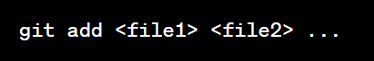

If you need to add all files,

git add .

1. **Commit the changes** - Once the files are added, you can commit the changes with a descriptive message.

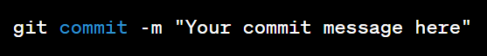

1. **Create a repository on GitHub -** Go to the GitHub website and create a new repository if you haven't already done so
2. **Add the remote repository** - In your terminal, add the remote repository URL using the following command(if it is a newly created repository)



1. **Push the changes to GitHub -** Finally, push the committed changes to the remote repository on GitHub.



1. **Finally, refresh the GitHub page and see the changes**